LAB 4
Q1
.data
arrayB BYTE 5h, 6h, 2h
arrayW WORD 15h, 5h, 10h
arrayD DWORD 60h, 12h, 18h
prod1 DWORD ?
prod2 DWORD ?
prod3 DWORD ?
.code
;PROD1 = arrayB[0] * arrayW[0] * arrayD[0]
movzx eax,arrayB[0]
mul arrayW[0]
mul arrayD[0]
mov ebx,eax
;PROD2 = arrayB[1] * arrayW[1] * arrayD[1]
movzx eax,arrayB[1]
mul arrayW[2]
mul arrayD[4]
mov ecx,eax
;PROD3 = arrayB[2] * arrayW[2] * arrayD[2]
movzx eax,arrayB[2]
mul arrayW[4]
mul arrayD[8]
mov edx,eax
call DumpRegs
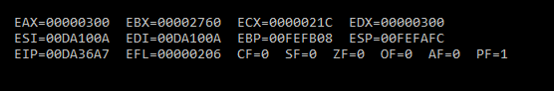

Q2
.data
u sbyte 5h
v sbyte 4h
w sbyte 8h
x sbyte 9h
y sbyte 6h
z sbyte ?
.code
;z = x + y + w – v +u
mov al,x
add al,y
add al,w
sub al,v
add al,u
mov z,al
mov ah,z
call DumpRegs

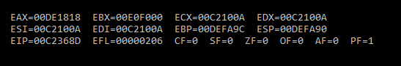

Q3
.data
array1 BYTE 10, 20, 30, 40
array2 WORD 4 DUP(?)
.code
mov esi,3
mov ecx,4
mov edi,0
L1:
movzx ax,array1[esi]
mov array2[edi],ax
inc edi
dec esi
loop L1
call DumpRegs

